EXPERIMENT NO : 3

NAME : SAHIL TRIPATHI

AIM : Write a Verilog code for 8:1 mux using

a)Data Flow Modeling

       b)Gate Level Modeling

Solution - TRUTH TABLE

|  |  |  |  |
| --- | --- | --- | --- |
| S2 | S1 | S0 | Y |
| 0 | 0 | 0 | I0 |
| 0 | 0 | 1 | I1 |
| 0 | 1 | 0 | I2 |
| 0 | 1 | 1 | I3 |
| 1 | 0 | 0 | I4 |
| 1 | 0 | 1 | I5 |
| 1 | 1 | 0 | I6 |
| 1 | 1 | 1 | I7 |

EXPERSSION OF Y –

Y=S2 S1 S0 I0+S2 S1 S0 I2 +S2 S1 S0 I2 + S2 S1 S0 I3 + S2 S1 S0 I4 + S2 S1 S0 I5 + S2 S1 S0 I6 + S2 S1 S0 I7

Note : yello mark indicate that they have bars means there value is 0

CIRCUIT DIAGRAM OF 8*1 MUX

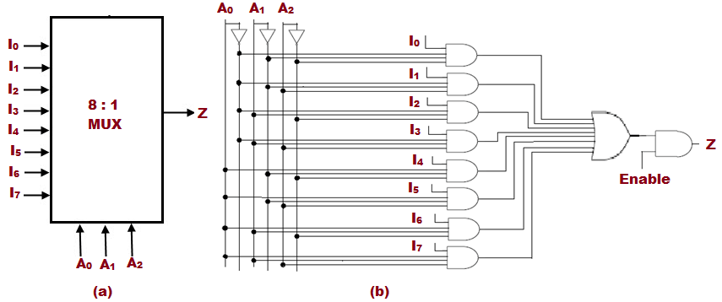

CODE FOR 8X1 MUX

module eight_one_mux(input I0, I1, I2, I3, I4, I5, I6, I7, S0, S1, S2, output out);

wire T1, T2, T3, T4, T5, T6, T7, T8, T9, T10, T11;

not(T1, S0);

not(T2, S1);

not(T3, S2);

and(T4, I0, T1, T2, T3), (T5, I1, S0, T2, T3);

and(T6, I2, T1, S1, T3), (T7, I3, S0, S1, T3);

and(T8, I4, T1, T2, S2), (T9, I5, S0, T2, S2);

and(T10, I6, T1, S1, S2), (T11, I7, S0, S1, S2);

or(out, T4, T5, T6, T7, T8, T9, T10, T11);

endmodule

IMAGE OF CODE –

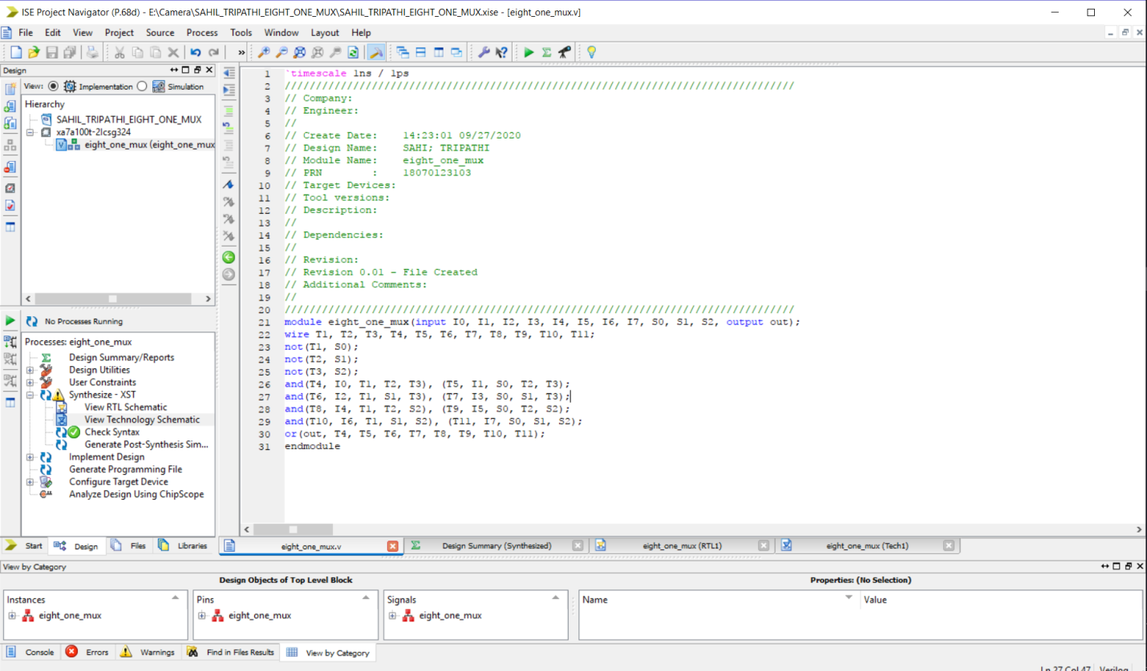

RTL SCHEMATICS

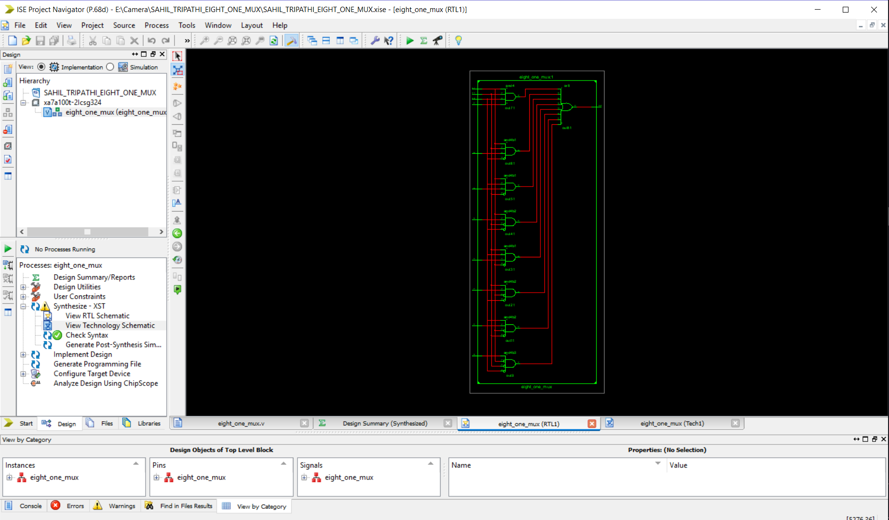

RTL TECHNOLOGY 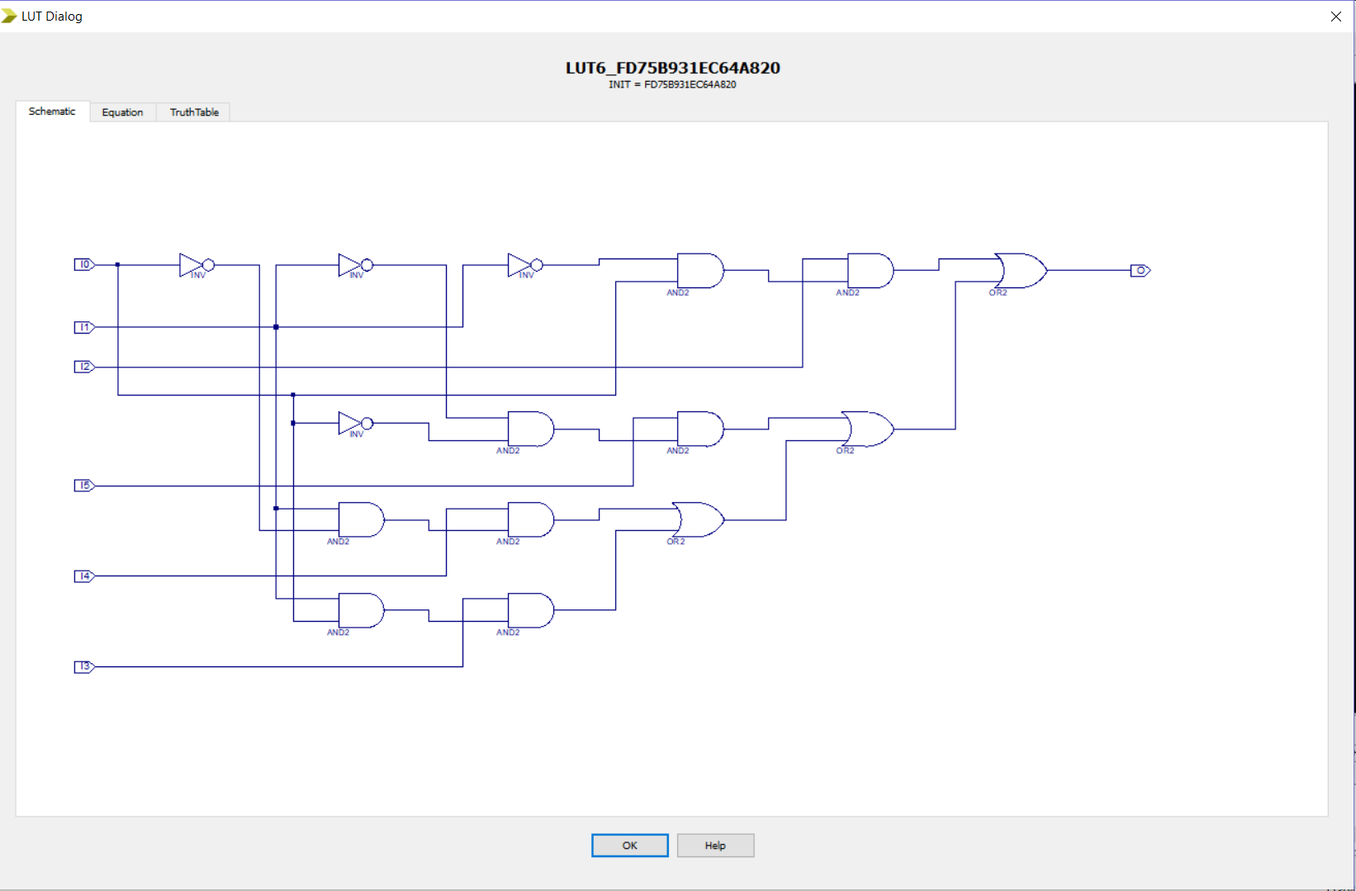

SIMULATION (FORCE-CONSTANT)

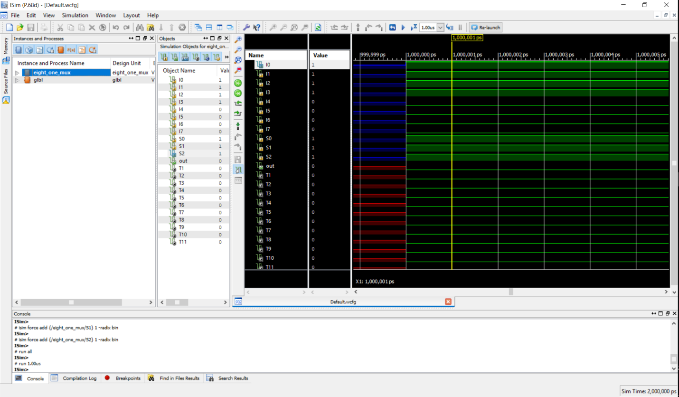

FORCE CLOCK-

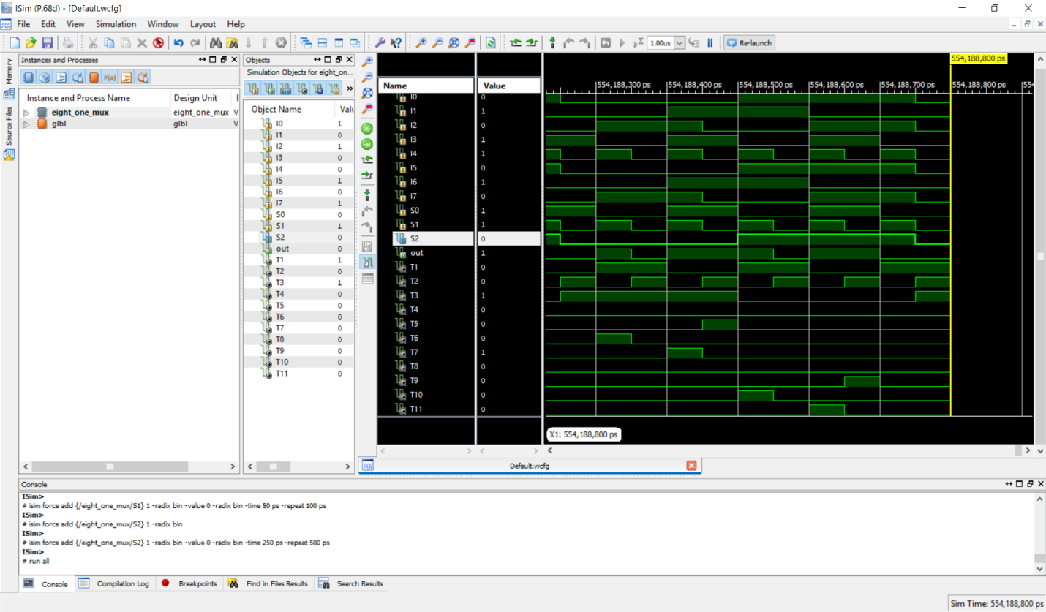

## 8X1 MUX USING DATA FLOW

CODE

module eight_one_mux_dataflow(

output out,

input I0, I1, I2, I3, I4, I5, I6, I7, S0, S1, S2

);

// NOT OPERATIONS

assign S1bar=~S1;

assign S0bar=~S0;

assign S2bar=~S2;

// using the equation of 8X1 mux

assign out = (I0 & S2bar & S1bar & S0bar) | (I1 & S2bar & S1bar & S0) | (I2 & S2bar & S1 & S0bar) + (I3 & S2bar & S1 & S0)

+ (I4 & S2 & S1bar & S0bar) + (I5 & S2 & S1bar & S0) + (I6 & S2 & S1 & S0bar) + (I7 & S2 & S1 & S0);

endmodule

IMAGE OF CODE-

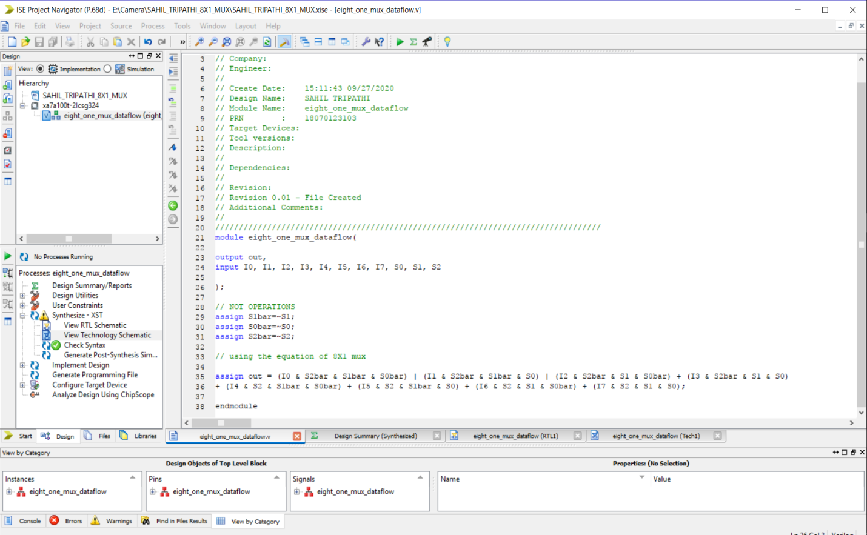

RTL SCHEMATIC

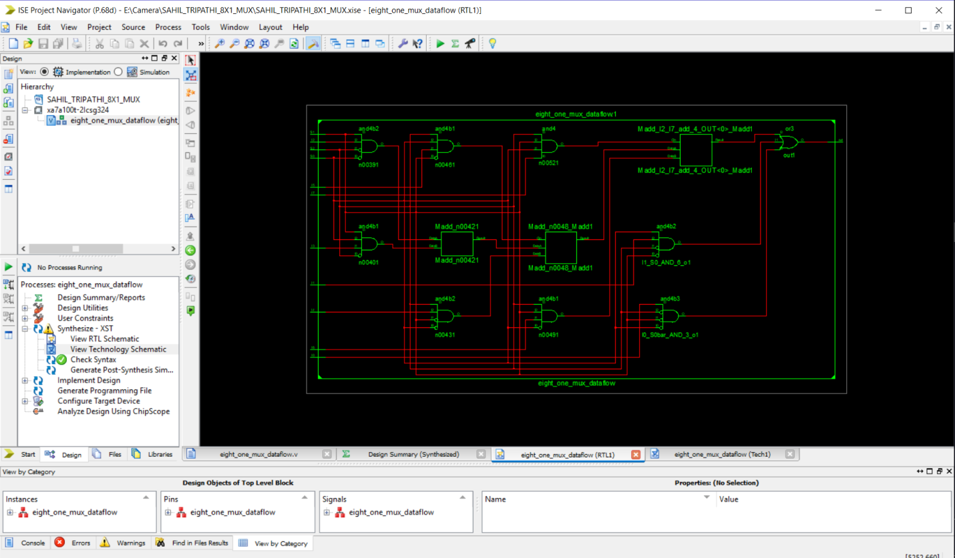

RTL TECHNOLOGY SCHEMATICS



SIMULATION

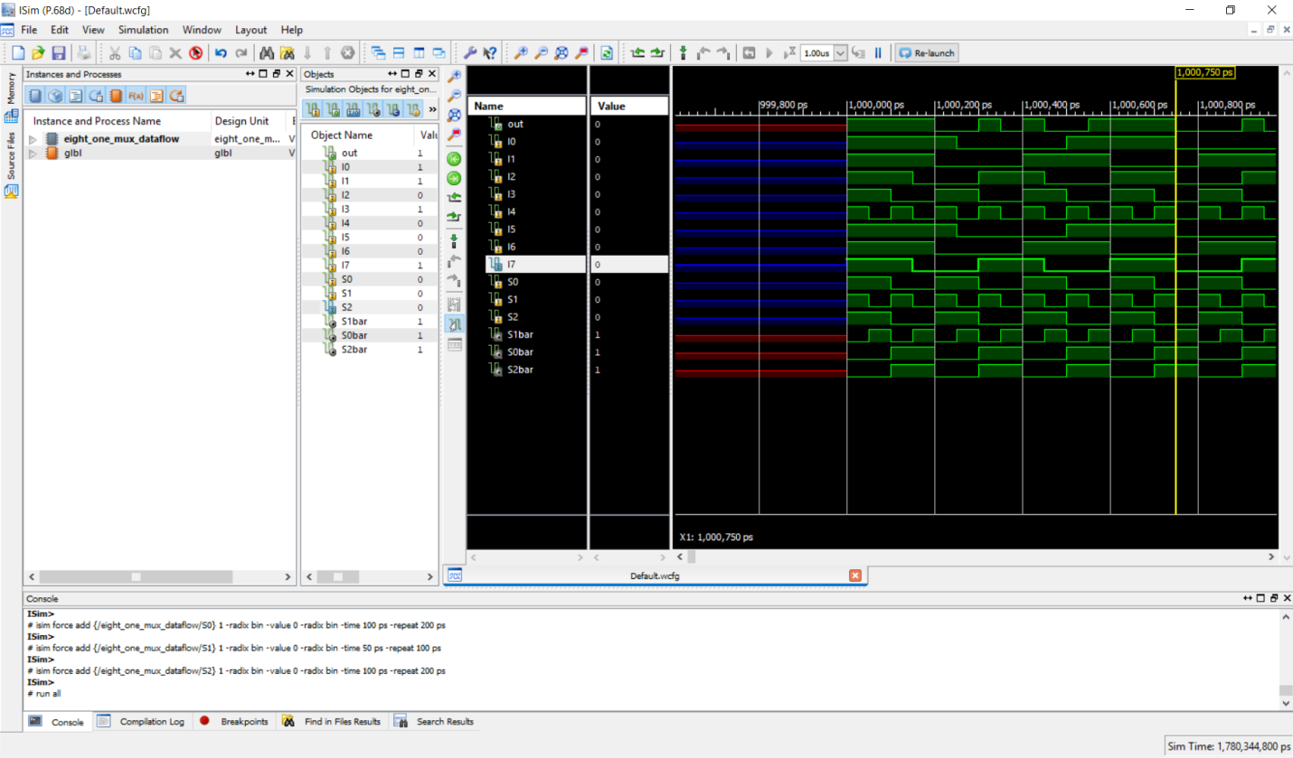

SO HENCE WE HAVE LEARNED HOW TO IMPLEMENT 8X1 MUX USING GATE LEVEL AND DATAFLOW SND SIMULATION IN XILIN SOFTWARE